Fundamentals - REST-API

**Labels: ArubaOS-CX Switches**

**Q:**

**What is the best way to update value of an existing resource using REST-API call ?**

Updating a resource here means changing the already created resource. For example, shutting down an interface, which was "admin" "up".

Using PUT method can get complicated and should be used with caution.

*The PUT operation is a replace operation—not an update operation—because the resource instance in the request body replaces every changeable configuration attribute of the existing resource. To update specific fields, use the PATCH operation.*

***Any mutable attribute that the JSON data in request body does not include is either removed (if there is no default value) or reset to its default value.***

Below we can see that we tried to shut down an interface using PUT method, but this resulted in other interface context configs to be removed. This happened because in the request body, value of other mutable attributes in interface context is not added appropriately. As a result, vlan gets defaulted to 1 and aaa authentication port-access auth-predence also gets defaulted to *aaa authentication port-access auth-predence dot1x mac-auth*.

[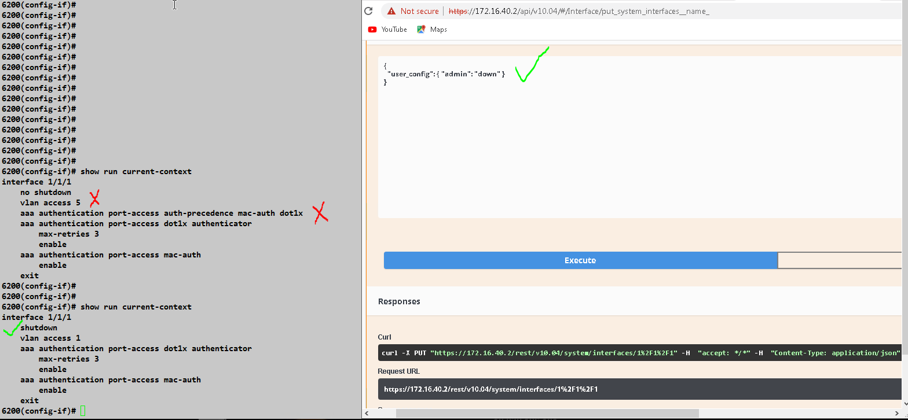](https://akb.arubanetworks.com/media/ckuploads/1110/2022/07/30/shutdown-on-interface-causes-few-config-removal.PNG)

**A:**

A better method is to use PATCH. By using PATCH method we do not need values of all other mutable attributes in the request body to update value of a single resource.

We could see from below JSON request body that only value of admin state resource is updated, rest of resources are untouched.

  {"user_config": {  
                              "admin": "*string*" }  
  }

string is*up* or *down*

[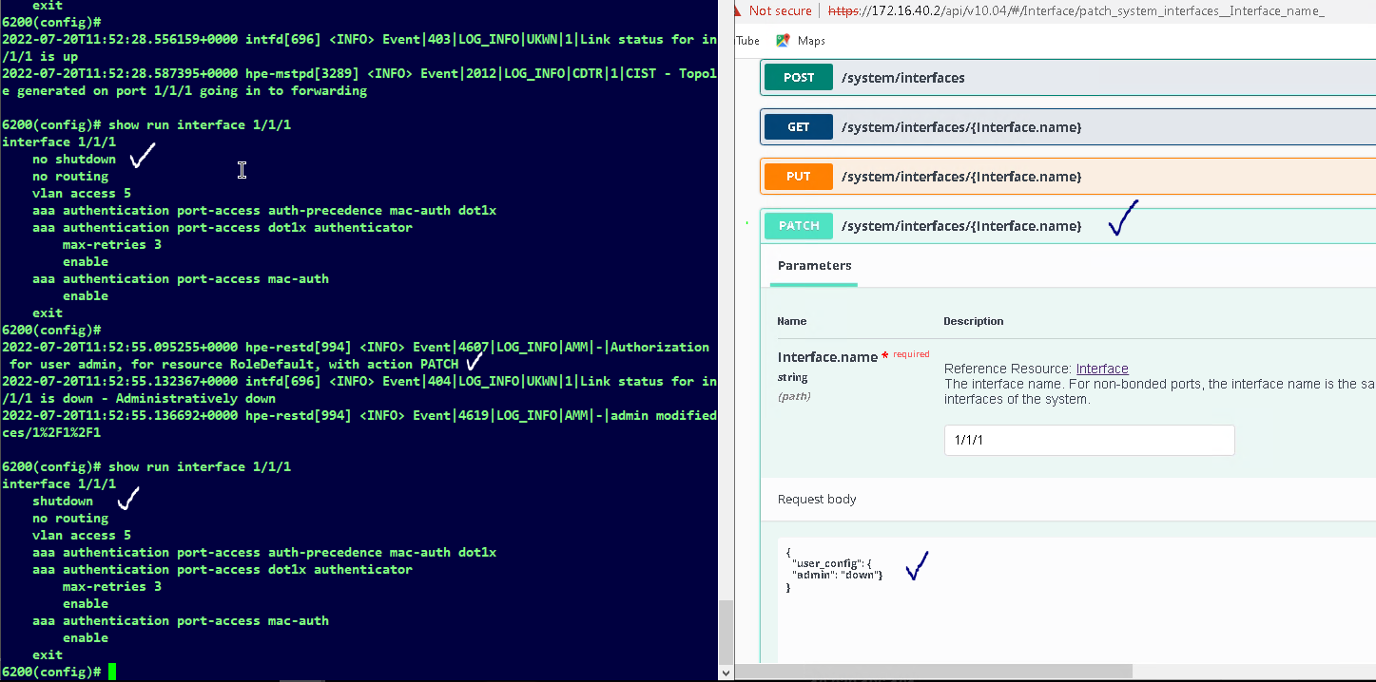](https://akb.arubanetworks.com/media/ckuploads/1110/2022/07/30/used-patch-to-shutdown-an-interface.PNG)

PATCH method is available from 10.09.XXXX onwards.

Tags: ArubaOS-CX Switches, 10.02.0010, patch, post, rest-api, #update